**Activity 20**

**NAME : Abinaya COURSE: MOBILE COMPUTING**

**REG NO : 192421208 COURSE CODE: ITA0302**

Design a wireframe in Figma for a mobile application showcasing power management

Approaches.

**Aim:**

Design a wireframe in Figma for a mobile application showcasing power management

Approaches.

**Procedure:**

1. Create a file

2. Add The First Frame

3. Add Shapes

4. Add Text

5. Create The Second Frame

6. Add Prototyping

Step By Step Procedure :

**Interface Of Experiment**

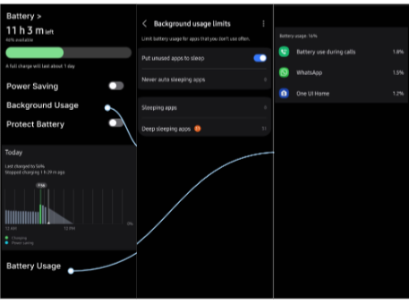

**Prototype:**

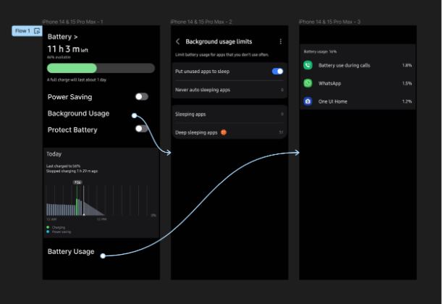

**Result:**

Hence the mobile application showcasing power management is created and executed

successfully.